**Hands on 5**

**Implement services for managing Country**

**Pom.xml**

<project xmlns="http://maven.apache.org/POM/4.0.0"

xmlns:xsi="http://www.w3.org/2001/XMLSchema-instance"

xsi:schemaLocation="

http://maven.apache.org/POM/4.0.0

http://maven.apache.org/xsd/maven-4.0.0.xsd">

<modelVersion>4.0.0</modelVersion>

<groupId>com.example</groupId>

<artifactId>countryapp</artifactId>

<version>1.0-SNAPSHOT</version>

<properties>

<java.version>17</java.version>

<spring.boot.version>3.2.5</spring.boot.version>

</properties>

<dependencies>

<dependency>

<groupId>org.springframework.boot</groupId>

<artifactId>spring-boot-starter-web</artifactId>

<version>${spring.boot.version}</version>

</dependency>

<dependency>

<groupId>org.springframework.boot</groupId>

<artifactId>spring-boot-starter-data-jpa</artifactId>

<version>${spring.boot.version}</version>

</dependency>

<dependency>

<groupId>com.mysql</groupId>

<artifactId>mysql-connector-j</artifactId>

<version>8.3.0</version>

</dependency>

<dependency>

<groupId>org.springframework.boot</groupId>

<artifactId>spring-boot-starter</artifactId>

<version>${spring.boot.version}</version>

</dependency>

</dependencies>

<build>

<plugins>

<plugin>

<groupId>org.springframework.boot</groupId>

<artifactId>spring-boot-maven-plugin</artifactId>

<version>${spring.boot.version}</version>

</plugin>

</plugins>

</build>

</project>

**CountryController.java**

package com.example.countryapp.controller;

import com.example.countryapp.model.Country;

import com.example.countryapp.service.CountryService;

import org.springframework.beans.factory.annotation.Autowired;

import org.springframework.web.bind.annotation.*;

import java.util.List;

@RestController

@RequestMapping("/countries")

public class CountryController {

@Autowired

private CountryService countryService;

@GetMapping("/{code}")

public Country getCountryByCode(@PathVariable String code) {

return countryService.getCountryByCode(code);

}

@PostMapping

public Country addCountry(@RequestBody Country country) {

return countryService.addCountry(country);

}

@PutMapping("/{code}")

public Country updateCountry(@PathVariable String code, @RequestBody Country country) {

return countryService.updateCountry(code, country);

}

@DeleteMapping("/{code}")

public String deleteCountry(@PathVariable String code) {

return countryService.deleteCountry(code);

}

@GetMapping("/search")

public List<Country> searchCountriesByName(@RequestParam String name) {

return countryService.searchCountriesByName(name);

}

}

**Country.java**

package com.example.countryapp.model;

import jakarta.persistence.Entity;

import jakarta.persistence.Id;

import jakarta.persistence.Table;

@Entity

@Table(name = "country")

public class Country {

@Id

private String coCode;

private String coName;

public String getCoCode() {

return coCode;

}

public void setCoCode(String coCode) {

this.coCode = coCode;

}

public String getCoName() {

return coName;

}

public void setCoName(String coName) {

this.coName = coName;

}

}

**CountryRepository.java**

package com.example.countryapp.repository;

import com.example.countryapp.model.Country;

import org.springframework.data.jpa.repository.JpaRepository;

import java.util.List;

public interface CountryRepository extends JpaRepository<Country, String> {

List<Country> findByCoNameContainingIgnoreCase(String name);

}

**CountryService.java**

package com.example.countryapp.service;

import com.example.countryapp.model.Country;

import com.example.countryapp.repository.CountryRepository;

import org.springframework.beans.factory.annotation.Autowired;

import org.springframework.stereotype.Service;

import java.util.List;

@Service

public class CountryService {

@Autowired

private CountryRepository countryRepository;

public Country getCountryByCode(String code) {

return countryRepository.findById(code).orElse(null);

}

public Country addCountry(Country country) {

return countryRepository.save(country);

}

public Country updateCountry(String code, Country updatedCountry) {

Country existing = countryRepository.findById(code).orElse(null);

if (existing != null) {

existing.setCoName(updatedCountry.getCoName());

return countryRepository.save(existing);

}

return null;

}

public String deleteCountry(String code) {

if (countryRepository.existsById(code)) {

countryRepository.deleteById(code);

return "Country deleted";

}

return "Country not found";

}

public List<Country> searchCountriesByName(String name) {

return countryRepository.findByCoNameContainingIgnoreCase(name);

}

}

**CountryAppApplication.java**

package com.example.countryapp;

import org.springframework.boot.SpringApplication;

import org.springframework.boot.autoconfigure.SpringBootApplication;

@SpringBootApplication

public class CountryAppApplication {

public static void main(String[] args) {

SpringApplication.run(CountryAppApplication.class, args);

System.out.println("Application started...");

}

}

**application.properties**

spring.datasource.url=jdbc:mysql://localhost:3306/countrydb

spring.datasource.username=root

spring.datasource.password=Sajitha_$2004

spring.jpa.hibernate.ddl-auto=update

spring.jpa.show-sql=true

spring.jpa.properties.hibernate.dialect=org.hibernate.dialect.MySQL8Dialect

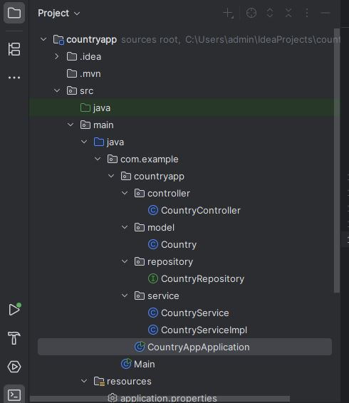

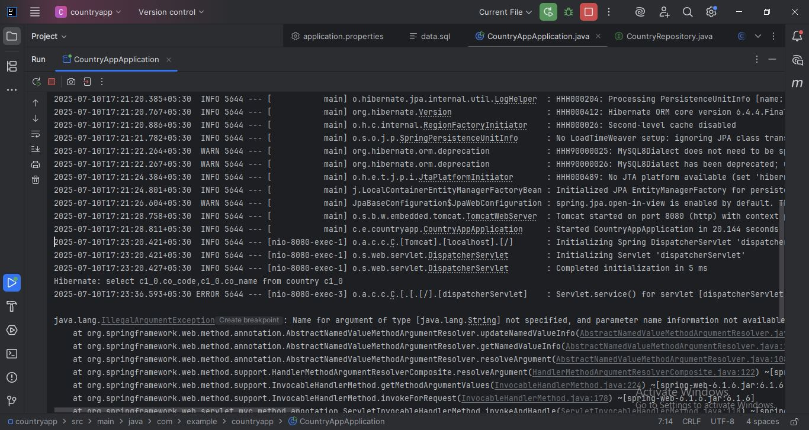

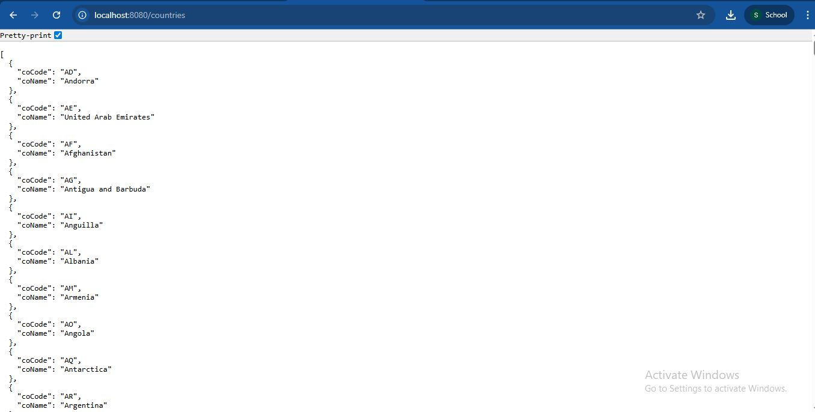

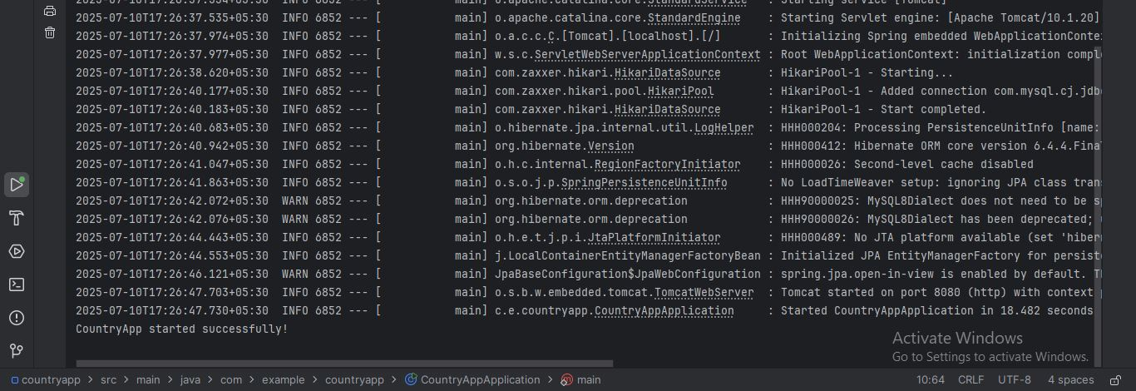

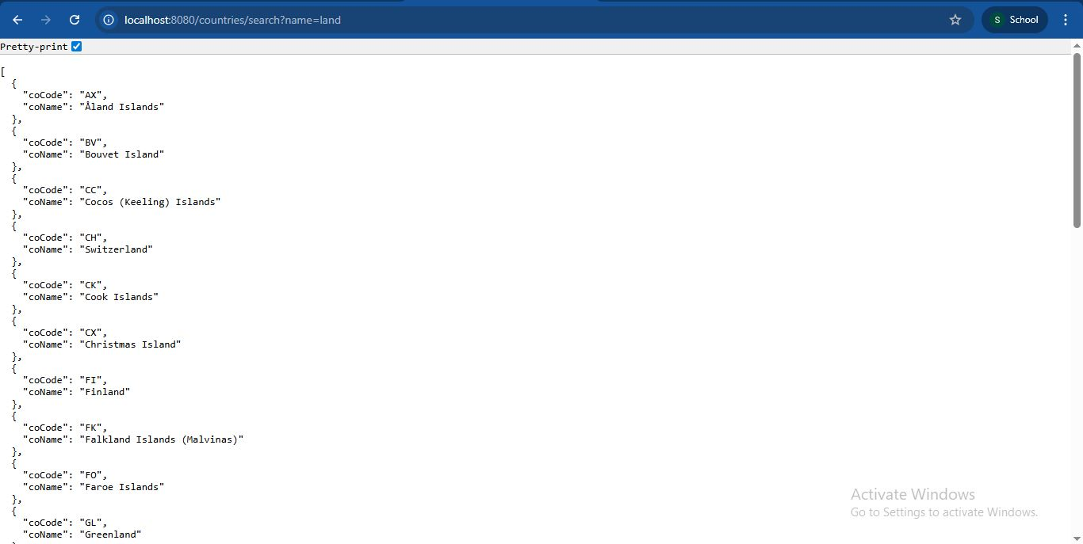

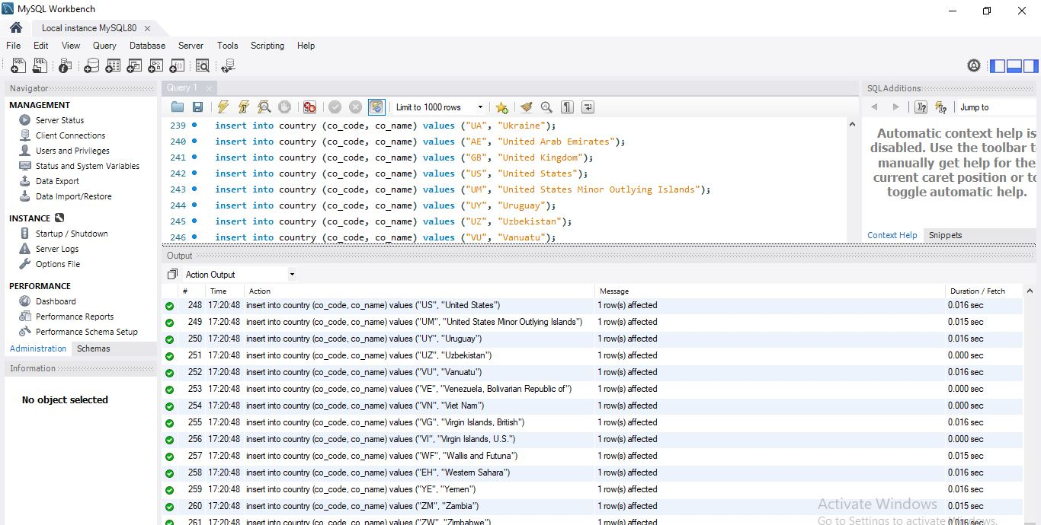

**hi 5 g.JPG**